**Pipeline**

Q1 A 5-stage pipelined RISCV datapath are illustrated in Fig. 1. Now we have the time information for each component tabulated in Table 1. What is the clock time and frequency of a pipelined CPU (ignore the branch comp and imm.)? (3 points)



Fig. 1 5-stage pipelined RSICV datapath

Table 1

|  |  |  |  |  |  |  |  |  |
| --- | --- | --- | --- | --- | --- | --- | --- | --- |
| Element | Register clk-to-q | Register Setup | MUX | ALU | Mem Read | Mem Write | RegFile Read | RegFile Setup |
| Parameter | tclk-to-q | tsetup | tmux | tALU | tMEMread | tMEMwrite | tRFread | tRFsetup |
| Delay(ps) | 30 | 20 | 25 | 250 | 400 | 500 | 200 | 50 |

**the Memory stage takes the longest time:**

READ: tclk-to-q + tmemread + tmux + tsetup = 30+400+25+20 = 475 ps

WRITE: tclk-to-q + tmemwrite = 30 + 500 = 530 ps

fclk,pipe = 1/tclk,pipe <= 1/ (530 ps) = 1.887 GHz

**Hazards**

Data hazards occur due to data dependencies among instructions. Forwarding can solve many data hazards.

Q2. Spot the data dependencies in the code below and figure out how forwarding can resolve

data hazards. (5 points)



The REG step for instructions 2 and 3 depend on data in the registers only available after the WB step of instruction 1. We can forward the ALU output of the first instruction to the EX stages of future instructions

Q3. In general, under what conditions will an EX stage need to take in forwarded inputs from

previous instructions? Where should those inputs come from in regards to the current cycle?

Assume you have the signals ALUout(n), rt(n), rs(n), regWrite(n), and regDst(n), where n is 0

for the signal of the current instruction being executed by the EX stage, -1 for the previous, etc.

For example,

Forward ALUout(-1) if (rs2(0) == regDst(-1) || rs1(0) == regDst(-1)) && regWrite(-1)

Please give other conditions. (6 points)

Forward ALUout(-2) if (rs2(0) == regDst(-2) || rs1(0) == regDst(-2)) && regWrite(-2)

Forward ALUout(-3) if (rs2(0) == regDst(-3) || rs1(0) == regDst(-3)) && regWrite(-3)

Q4. Spot the data dependencies in the code below and figure out why forwarding cannot

resolve this hazard. What can we do to solve this data hazard? (6 points)



The add instruction needs the value of t0 in the beginning of C3, but it is ready at the end of C3.



We can insert a nop into the load delay slot as shown above, or even better we can reorder instructions and fill up the load delay slot with an instruction to avoid performance loss.

Q5. Given the RISC-V code below and a pipelined CPU with no forwarding, how many hazards

would there be? What types are each hazard? Consider all possible hazards from all pairs of

instructions. How many stalls would there need to be in order to fix the data hazard(s)? What about the

control hazard(s)? (6 points)



**hazards from 1-2, 1-3, 2-3, 4-5**

**4-5 is a control hazard, all others are data hazard.**

**Assuming concurrent reads and writes to registers are possible, two stalls for instruction 2 are needed for register t0 between 1 and 2, two stalls are needed for the register s2 between 2 and 3.**

**Either flush the pipeline or use branch prediction to deal with the control hazard.**

**Out-of-Order Scheduling**

Q6. This problem deals with an out-of-order single-issue processor that is based on the basic RISC-V pipeline and has a floating-point unit. The FPU has one adder, one multiplier, and one load/store unit. The adder has a two-cycle latency and is fully pipelined. The multiplier has a six-cycle latency and is fully pipelined. Assume that stores take one cycle and loads take two cycles.

There are 31 integer registers (x1-x32) and 32 floating-point registers (f0-f31). To maximize number of instructions that can be in the pipeline, register renaming is used. The decode stage can add up to one instruction per cycle to the re-order buffer (ROB). The CPU uses a data-in-ROB design, so there is one rename register associated with each ROB entry. Functional units write back to the ROB upon completion. The functional units share a single write port to the ROB. In the case of a write-back conflict, the older instruction writes back first. The instructions are committed in order and only one instruction may be committed per cycle. The earliest time an instruction can be committed is one cycle after write back.

Floating-point instructions (including loads writing floating-point registers) must spend one cycle in the write-back stage before their result can be used. Integer results are available for bypass the next cycle after issue and write back two cycles after issue.

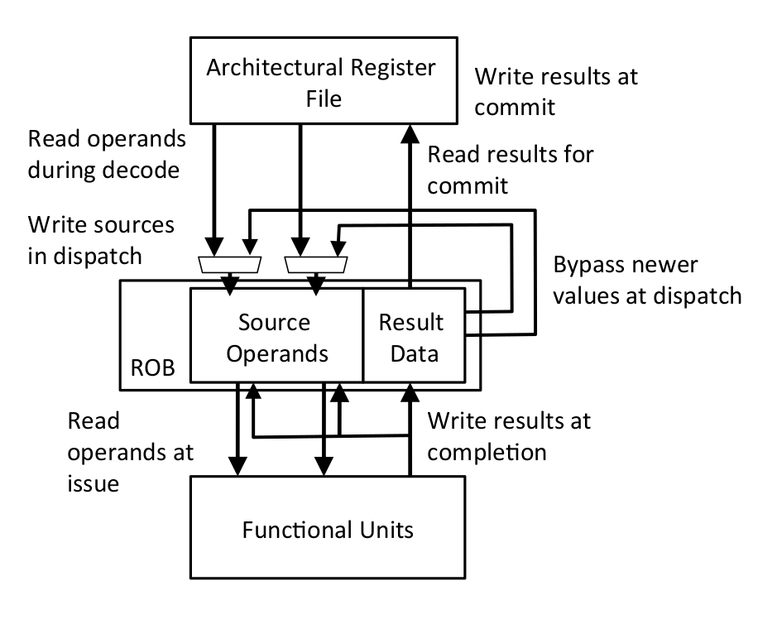

For the following questions, we will evaluate the performance of the code segment below.

|  |  |
| --- | --- |
| I1 | FLD f1, 0(x1) |
| I2 | FMUL.D f2, f1, f0 |
| I3 | FADD.D f3, f2, f0 |
| I4 | ADDI x1, x1, 8 |
| I5 | FLD f1, 0(x1) |
| I6 | FMUL.D f2, f1, f1 |
| I7 | FADD.D f2, f2, f3 |

1. For this part, consider an ideal case where we have an unlimited number of ROB entries.

In the table below, fill in the cycle number for when each instruction enters the ROB, issues, writes back, and commits. Also, fill in the new register names for each instruction, where applicable. (10 points)

Since we have an infinite supply of register names, you should use a new register name for each register that is written (p0, p1, … ). Keep in mind that after a register has been renamed, subsequent instructions that refer to that register must refer to the new register name.

|  |  |  |  |  |  |  |  |  |
| --- | --- | --- | --- | --- | --- | --- | --- | --- |
|  | Time | | | | OP | Dest | Src1 | Src2 |
| Enter RO) | Issue | W) | Commit |
| I1 | -1 | 0 | 2 | 3 | FLD | p0 | x1 | - |
| I2 | 0 | 3 | 9 | 10 | FMUL.D | p1 | p0 | f0 |
| I3 | 1 | 10 | 12 | 13 | FADD.D | p2 | p1 | f0 |
| I4 | 2 | 4 | 6 | 14 | ADDI | p3 | x1 | - |
| I5 | 3 | 5 | 7 | 15 | FLD | p4 | p3 | - |
| I6 | 4 | 8 | 14 | 16 | FMUL.D | p5 | p4 | p4 |
| I7 | 5 | 15 | 17 | 18 | FADD.D | p6 | p5 | p2 |

1. For this part, consider a more realistic system with a four-entry ROB. An ROB entry can be used one cycle after the instruction using it commits. Fill in the table as you did in part A. If the instruction uses a source register that has already been retired, use the architectural name of the register. (10 points)

|  |  |  |  |  |  |  |  |  |
| --- | --- | --- | --- | --- | --- | --- | --- | --- |
|  | Time | | | | OP | Dest | Src1 | Src2 |
| Enter RO) | Issue | W) | Commit |
| I1 | -1 | 0 | 2 | 3 | FLD | p0 | x1 | - |
| I2 | 0 | 3 | 9 | 10 | FMUL.D | p1 | p0 | f0 |
| I3 | 1 | 10 | 12 | 13 | FADD.D | p2 | p1 | f0 |
| I4 | 2 | 4 | 6 | 14 | ADDI | p3 | x1 | - |
| I5 | 4 | 5 | 7 | 15 | FLD | p0 | p3 | - |
| I6 | 11 | 12 | 18 | 19 | FMUL.D | p1 | p0 | p0 |
| I7 | 14 | 19 | 21 | 22 | FADD.D | p2 | p1 | f3 |

**Unified Physical Register Files**

Q7. In this problem, we’ll consider an out-of-order CPU design using a unified physical register file. All of the data, both retired and inflight, are kept in the same physical register file. The pipeline contains a remap file that is indexed by the architectural register number and stores the physical register number the architectural register maps to. The physical register file contains the register data and a bit indicating whether the data is valid or not. The pipeline also contains a free list, which is a FIFO queue containing the physical register numbers that are not yet mapped to architectural registers. On issue, the current mappings of the destination register and two source registers are read from the remap file and stored in the ROB. The head of the free list is then popped off and written to the entry for the destination architectural register in the remap file. On a mispredict or exception, the remap file can be restored by going backwards through the ROB and restoring the old physical register mappings.

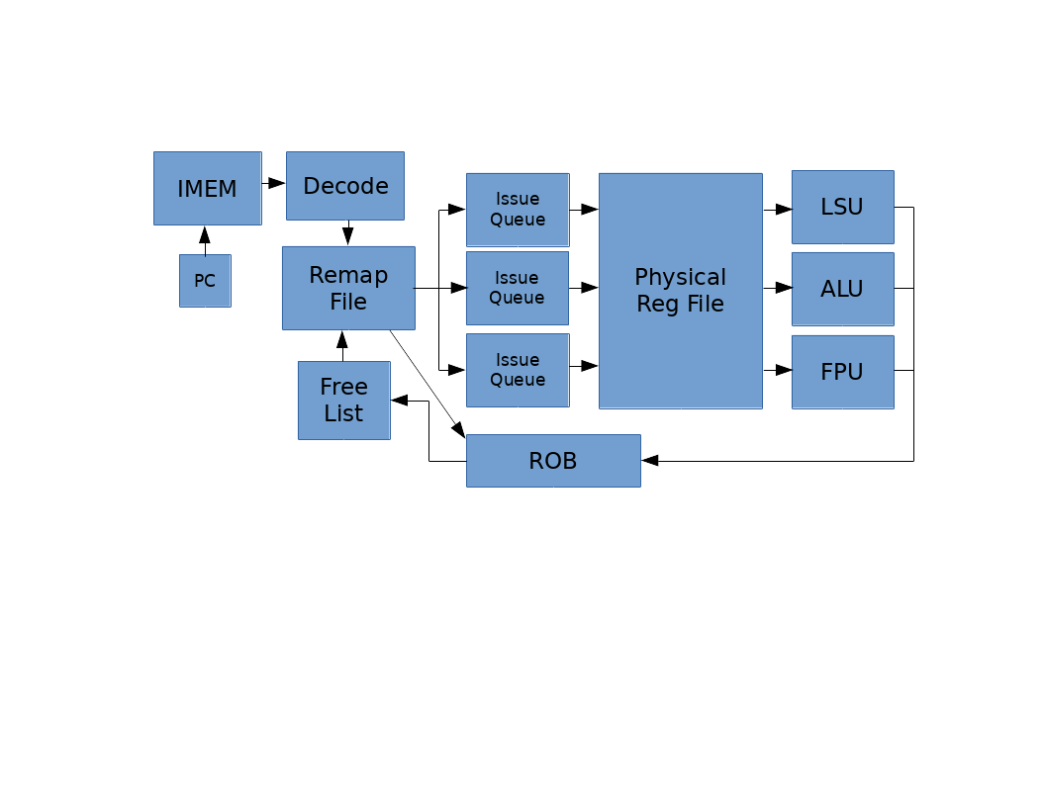

1. Consider a system with eight architectural registers, sixteen physical registers, and a four-entry ROB. The following table shows the ROB when a exception occurs in the instruction indicated in bold.

|  |  |  |  |
| --- | --- | --- | --- |
|  | ROB PC | Arch. Register | Old Phys. Register |
|  | 0x80001008 | x1 | p9 |
| tail -> | 0x8000100C | x2 | p8 |
| head -> | 0x80001010 | x6 | p5 |
|  | **0x80001014** | x2 | p11 |

The left column of the following table shows the state of the remap file when the exception is detected. Fill out the right column to show the restored state. (8 points)

|  |  |  |
| --- | --- | --- |
| Arch Reg | Current State | Restored State |
| x0 | p1 | p1 |
| x1 | p6 | p9 |
| x2 | p2 | p11 |
| x3 | p10 | p10 |
| x4 | p7 | p7 |
| x5 | p4 | p4 |
| x6 | p13 | p13 |
| x7 | p15 | p15 |

1. When can a physical register be released and put back on the free list? (5 points)

There are two situations in which a physical register can be put back on the free list. If an instruction is invalidated by an exception, its destination physical register can be put back on the free list. When an instruction retires, the old physical register for its destination architectural register can be put back on the free list.

1. How many physical registers must there be so that the pipeline never stalls due to lack of physical registers in the free list? (5 points)

The number of physical registers should be the number of architectural registers plus the number of RO) entries. If this is the case, then there will always be a free physical register for each free RO) entry, since a physical register will be released for each RO) entry that retires.

1. Here are some of the initial register mappings and the free list for a RISC-V OoO CPU with a unified physical register file (integer and floating point regs in same physical register file). (8 points)

|  |  |  |  |
| --- | --- | --- | --- |
| Arch Register | Phys Register |  | Free List |
| f0 | p5 | p6 |
| f1 | p12 | p19 |
| f2 | p11 | p10 |
| x2 | p8 | p21 |
| x3 | p24 | p27 |
| x4 | p17 |  |

For the following instruction sequence, indicate which physical register gets assigned as the destination register and which physical register gets added to the free list on commit.

|  |  |  |  |  |
| --- | --- | --- | --- | --- |
| Instruction | | | Destination Register | Freed Register |
| fld | f0, | 0(x2) | p6 | p5 |
| fld | f1, | 0(x3) | p19 | p12 |
| fmul.d | f0, | f0, f2 | p10 | p6 |
| fadd.d | f0, | f0, f1 | p21 | p10 |
| fsd | f0, | 0(x4) | - | - |
| addi | x2, | x2, 8 | p27 | p8 |
| addi | x3, | x3, 8 | p5 | p24 |
| addi | x4, | x4, 8 | p12 | p17 |

1. If we wanted to implement register renaming in a superscalar OoO core that can issue two instructions per cycle, what would we have to change? (6 points)

The danger is that the two instructions we issue in the same cycle have a hazard between them. In that case, renaming them independently would cause wrong labels to be assigned. For example, in case of a RAW hazard, the destination register of the frst instruction need to be the same physical register as the read register of the second instruction. We need to add a bypass to make this happen because in the same cycle that the second instruction reads the rename table, the frst instruction has not updated it yet. The same is true of WAW hazards. If the second instruction writes to the same architectural register as the frst, its previous physical destination register must be the physical destination register used by the frst, not the current entry in the remap table.

**Pipelining with Branch Prediction**

Q8. For this question, consider a fully bypassed 5-stage RISC-V processor. We have reproduced the pipeline diagram below (bypasses are not shown). Branches are resolved in the Execute Stage, and the Fetch Stage always speculates that the next PC is PC+4. For this problem, we will ignore unconditional jumps, and only concern ourselves with conditional branches.

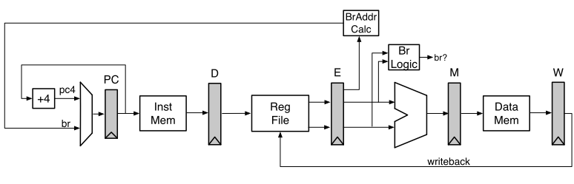

1. Fill in the following pipeline diagram using the code segment below. The first two instructions have been done for you. (5 points)

Throughout this question, make sure you also show instructions that were speculated to be executed and then flushed (it would help to mark them explicitly) in the instruction/time diagrams, as they also consume pipeline resources.

|  |
| --- |
| 0x2000: ADDI x4, x0, 1  0x2004: ADDI x5, x0, 1  0x2008: BEQ x4, x5, 0x2004  0x200c: LW x7, 4(x6)  0x2010: OR x5, x7, x5  0x2014: XOR x7, x7, x3  0x2018: AND x3, x2, x3 |

|  |  |  |  |  |  |  |  |  |  |  |  |  |  |  |
| --- | --- | --- | --- | --- | --- | --- | --- | --- | --- | --- | --- | --- | --- | --- |
| PC | Instr | t1 | t2 | t3 | t4 | t5 | t6 | t7 | t8 | t9 | t10 | t11 | t12 | t13 |
| 0x2000 | ADDI | F | D | X | M | W |  |  |  |  |  |  |  |  |
| 0x2004 | ADDI |  | F | D | X | M | W |  |  |  |  |  |  |  |
| 0x2008 | )EQ |  |  | F | D | **X** | M | W |  |  |  |  |  |  |
| 0x200c | LW |  |  |  | F | D | - | - | - |  |  |  |  |  |
| 0x2010 | OR |  |  |  |  | F | - | - | - | - | - |  |  |  |
| 0x2004 | ADDI |  |  |  |  |  | F | D | X | M | W |  |  |  |
| 0x2008 | )EQ |  |  |  |  |  |  | F | D | X | M | W |  |  |

The point in time that a branch comparison occurs is underlined above. The IF_KILL and DEC_KILL signal goes out in t5, when the “mispredict” is discovered. )ubbles are inserted into the pipeline, and show up on t6.

1. As you showed in the first parts of this question, branches in RISC-V can be expensive in a 5-stage pipeline. One way to help reduce this branch penalty is to add a Branch History Table (BHT) to the processor. This new proposed datapath is shown below:

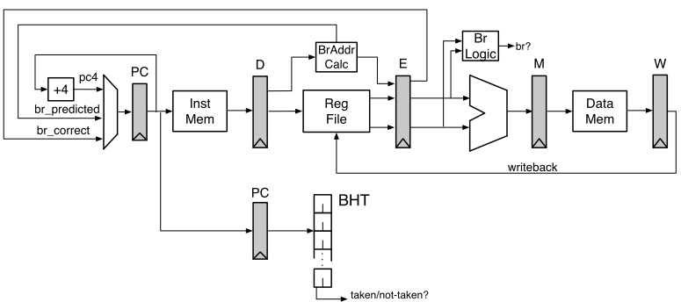

The BHT has been added in the Decode Stage. The BHT is indexed by the PC register in the Decode Stage. Branch address calculation has been moved to the Decode Stage. This allows the processor to redirect the PC if the BHT predicts “Taken”.

On a BHT mis-prediction, (1) the branch comparison logic in the Execute Stage detects mis-predicts, (2) kills the appropriates stages, and (3) starts the Instruction Fetch using the correct branch target (br_correct).

Remember: the Fetch Stage is still predicting PC+4 every cycle, unless corrected by either the BHT in the Decode Stage(br_predicted) or by the branch logic in the Execute Stage(br_correct).

Using the code segment below, fill in the following pipeline diagram. Initially, the BHT counters are all initialized to “strongly-taken”. The register x2 is initialized to 0, while the register x3 is initialized to 2. The first instruction has been done for you. It is okay if you do not use the entire table. (6 points)

|  |
| --- |
| 0x2000: LW x7, 0(x6)  0x2004: ADDI x2, x2, 1  0x2008: BEQ x2, x3, 0x2000  0x200c: SW x7, 0(x6)  0x2010: OR x5, x5, 4  0x2014: OR x7, x7, 5 |

Loop is not taken. The BHT is “strongly” taken, so BHT predicts “taken” when we see BEQ. BHT is in Decode, and Fetch stage always predicts PC+4, so we eat 1 cycle when the BHT predicts taken branch, and we eat another cycle if BHT predicts taken, but branch is actually not taken (i.e., it just degregates to the original 2-cycle branch penalty). At t4 (as circled), the Decode stage kills the fetch stage to redirect it down the “taken” path. However, at t5 we resolve the branch comparison in Execute and must correct for the BHT’s misprediction, and kill Fetch and Decode.

|  |  |  |  |  |  |  |  |  |  |  |  |  |  |  |
| --- | --- | --- | --- | --- | --- | --- | --- | --- | --- | --- | --- | --- | --- | --- |
| PC | Instr | t1 | t2 | t3 | t4 | t5 | t6 | t7 | t8 | t9 | t10 | t11 | t12 | t13 |
| 0x2000 | LW | F | D | X | M | W |  |  |  |  |  |  |  |  |
| 0x2004 | ADDI |  | F | D | X | M | W |  |  |  |  |  |  |  |
| 0x2008 | BEQ |  |  | F | **D** | **X** | M | W |  |  |  |  |  |  |
| 0x200c | SW |  |  |  | F | - | - | - | - |  |  |  |  |  |
| 0x2000 | LW |  |  |  |  | F | - | - | - | - | - |  |  |  |
| 0x200c | SW |  |  |  |  |  | F | D | X | M | W |  |  |  |
| 0x2010 | OR |  |  |  |  |  |  | F | D | X | M | W |  |  |
| 0x2014 | OR |  |  |  |  |  |  |  | F | D | X | M | W |  |

1. Unfortunately, while the BHT is an improvement, we still have to wait until we know the branch address to act on the BHT’s prediction. We can solve this by using a two-entry Branch Target Buffer (BTB).

The new pipeline is shown below. For this question, we have removed the BHT and will only be using the BTB.

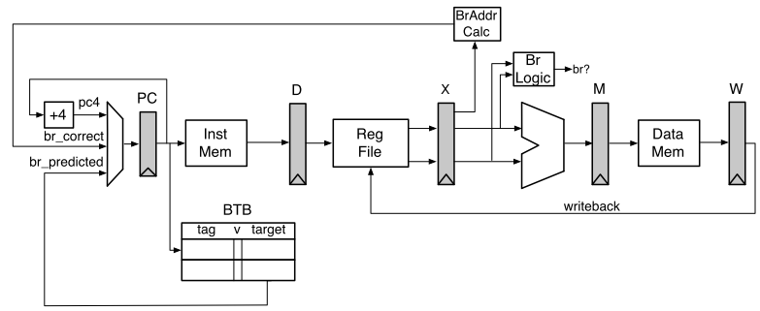

The BTB has been added in the Fetch Stage. The BTB is indexed by the PC register in the Fetch Stage. Branch address calculation has been moved back to the Execute Stage.

On a branch mis-prediction, (1) the branch comparison logic in the Execute Stage detects the mis-predict, (2) kills the appropriates stages, and (3) starts the Instruction Fetch using the correct branch target (br_correct).

Remember: the Fetch Stage is still predicting PC+4 every cycle, unless either the BTB makes a prediction (has a matching and valid entry for the current PC) or the branch logic in the Execute Stage corrects for a branch mis-prediction (br_correct).

Using the code segment below (the exact same code from 4.B), fill in the following pipeline diagram. Upon entrance to this code segment, the register x2 is initialized to 0, while the register x3 is initialized to 2.

|  |
| --- |
| 0x2000: LW x7, 0(x6)  0x2004: ADDI x2, x2, 1  0x2008: BEQ x2, x3, 0x2000  0x200c: SW x7, 0(x6)  0x2010: OR x5, x5, 4  0x2014: OR x7, x7, 5 |

Initially, the BTB contains:

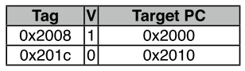

(For simplicity, the Tag is 32-bits, and we match the entire 32-bit PC register in the Decode Stage to verify a match). It is okay if you do not use the entire instruction/time table. (6 points)

|  |  |  |  |  |  |  |  |  |  |  |  |  |  |  |
| --- | --- | --- | --- | --- | --- | --- | --- | --- | --- | --- | --- | --- | --- | --- |
| PC | Instr | t1 | t2 | t3 | t4 | t5 | t6 | t7 | t8 | t9 | t10 | t11 | t12 | t13 |
| 0x2000 | LW | F | D | X | M | W |  |  |  |  |  |  |  |  |
| 0x2004 | ADDI |  | F | D | X | M | W |  |  |  |  |  |  |  |
| 0x2008 | BEQ |  |  | F | D | **X** | M | W |  |  |  |  |  |  |
| 0x2000 | LW |  |  |  | F | D | - | - | - |  |  |  |  |  |
| 0x2004 | ADDI |  |  |  |  | F | - | - | - | - |  |  |  |  |
| 0x200c | SW |  |  |  |  |  | F | D | X | M | W |  |  |  |
| 0x2010 | OR |  |  |  |  |  |  | F | D | X | M | W |  |  |
| 0x2014 | OR |  |  |  |  |  |  |  | F | D | X | M | W |  |

When the BEQ instruction is in the fetch stage, the BTB finds a valid entry tagged with the PC, so it incorrectly predicts the branch will be taken and fetches the LW instruction. The misprediction isn’t detected until two cycles later, when the BEQ instruction reaches the Execute stage. So two instructions will have erroneously entered the pipeline and must be cleared.

**Load/Store Speculation**

Q9.

1. Suppose we want to execute stores out-of-order. Could there be an issue if we allow stores to write to the cache even when there are uncommitted instructions before them in program order? (5 points)

Yes, executing stores ahead of other instructions and writing to the cache before commit can lead to the following issues.

* 1. Imprecise exceptions: If an instruction before the store in program order has an exception, you have to roll back the architectural state. This is hard to do if you’ve already modifed the cache contents. The same is true if the store is the result of a mispredicted branch.
  2. Memory ordering: If there are load or store instructions to the same address before the completed store in program order, writing to the cache on completion will change the program’s behavior from what would happen if executed in-order.

1. Suppose we bypass load values from a speculative store buffer. If the load address hits in both the store buffer and the cache, which one should we use: the data forwarded from the store buffer or the data from the cache? (5 points)

If the store buffer hit corresponds to a store instruction that comes before the load in program order, we should take the store buffer data. If the store instruction comes after the load instruction in program order, we should take the cache data.

1. Suppose that we want loads and stores to execute out-of-order with respect to each other. Under what circumstances in the code below can we execute instruction 5 before executing any others? (5 points)
   1. add x1, x1, x2
   2. sw x5, (x2)
   3. lw x6, (x8)
   4. sw x5, (x6)
   5. lw x9, (x3)
   6. add x9, x9, x9

We can only execute instruction 5 before the others if the address it is loading from does not overlap the addresses being stored to in instructions 2 and 4. So |x2 – x3| ≥ 4 and |x6 – x3| ≥ 4.

1. Under what circumstances can we execute instruction 4 in the code above before executing any others? (5 points)

Instruction 4 has a RAW hazard with instruction 3 because it depends on the value of register x6 that is being loaded by instruction 3. Therefore, it cannot execute first. It does not have any dependencies on any other instruction, since stores do not change architectural state until they are committed, so it can execute as soon as instruction 3 completes.

1. Now lets assume that we execute instruction 5 before all other instructions, but instruction 5 causes an exception (e.g., page fault). We want to provide precise exceptions in this processor. What happens with instructions 1, 2, 3, 4, and 6 before execution switches to the OS handler? What should happen if instructions, 1, 2, 3, or 4 also raise an exception? (5 points)

To provide precise exceptions, we have to execute and commit all instructions prior to instruction 5 before switching to the OS handler. Instruction 6 must be killed (thus not commit) because it’s after 5. If instructions 1, 2, 3, or 4 also raise an exception, the earliest instruction to have an exception should take precedent, and all later instructions should be flushed from the pipeline.

1. How can we always be able to execute loads and stores out of order before their addresses are known? What is the downside and how is it handled? Specifically, assume that we executed instruction 5 before instruction 4, but then realized that |x6 – x3| < 4. (5 points)

We can speculatively assume that addresses of all loads and stores are non- overlapping and issue them before knowing their addresses. Once addresses become known, if we realize that we shouldn’t have reordered some loads and stores, we have to terminate the ones we shouldn’t have executed as well as any further instructions that depend on them. In the example, we have to terminate instruction 5 as well as 6 once we fgure out that |x6-x3| < 4. Once instruction 4 completes, we then re-execute instructions 5 and 6.

**Branch Predictor Accuracy**

Q10. For this problem, we are interested in the following code:

int array[N] = {…};

for (int i = 0; i < N; i++)

if (array[i] != 0)

array[i]++;

Using the disassembler, we get:

li a0, N

la a1, array

loop:

lw a2, 0(a1)

beqz a2, endif

addi a2, a2, 1

sw a2, 0(a1)

endif:

addi a0, a0, -1

addi a1, a1, 4

bnez a0, loop

1. *Full BHT*

The processor that this code runs on uses a 512-entry branch history table (BHT), indexed by PC [10:2]. Each entry in the BHT contains a 2-bit counter, initialized to the 00 state.

Each 2-bit counter works as follows: the state of the 2-bit counter decides whether the branch is predicted taken or not taken, as shown in the table below. If the branch is actually taken, the counter is incremented (e.g., state 00 becomes state 01). If the branch is not taken, the counter is decremented. The counter saturates at 00 and 11 (a not-taken branch while in the 00 state keeps the 2-bit counter in the 00 state).

|  |  |
| --- | --- |
| State | Prediction |
| 00 | Not taken |
| 01 | Not taken |
| 10 | Taken |
| 11 | Taken |

If array = {1,0,-3,2,1}, what is the prediction accuracy for the two branches found in the above code for five iterations of the loop, using the 512-entry BHT described above? (10 points)

The five invocations of the **loop** branch are shown below. The prediction accuracy is 2/5.

|  |  |  |
| --- | --- | --- |
| State | Prediction | Actual |
| 00 | Not taken | Taken |
| 01 | Not taken | Taken |
| 10 | Taken | Taken |
| 11 | Taken | Taken |
| 11 | Taken | Not taken |

The five invocations of the **if** branch are shown below. The prediction accuracy is 4/5.

|  |  |  |
| --- | --- | --- |
| State | Prediction | Actual |
| 00 | Not taken | Not taken |
| 00 | Not taken | Taken |
| 01 | Not taken | Not taken |
| 00 | Not taken | Not taken |
| 00 | Not taken | Not taken |

1. *Small BHT*

Now consider a BHT with only a single entry. That is, both branches will share the same counter. Now what will the prediction accuracy be for each branch? Assume we are using the same array, {1,0,-3,2,1}. (10 points)

The ten branch invocations are shown below. In this case, the branch predictor had 3/5 accuracy for the **loop** branch and 1/5 accuracy for the **if** branch. So the accuracy decreased in general, as we expected.

|  |  |  |  |
| --- | --- | --- | --- |
| Branch | State | Prediction | Actual |
| if0 | 00 | Not taken | Not taken |
| loop0 | 00 | Not taken | Taken |
| if1 | 01 | Not taken | Taken |
| loop1 | 10 | Taken | Taken |
| if2 | 11 | Taken | Not taken |
| loop2 | 10 | Taken | Taken |
| if3 | 11 | Taken | Not taken |
| loop3 | 10 | Taken | Taken |
| if4 | 11 | Taken | Not taken |
| loop4 | 10 | Taken | Not taken |

1. *Static Hints*

For this question, assume that the compiler can specify statically which way the processor should predict the branch will go. If the processor sees a "branch-likely" hint from the compiler, it predicts the branch is taken and does NOT update the BHT with this branch (i.e., any branches the compiler can analyze do not pollute the BHT).

Which branches in the program, if any, can the compiler provides hints for? Assume the input array for the compiler's test runs varies widely and the compiler must be fairly confident in the accuracy of a static branch hint. (5 points)

The compiler can statically hint that the loop branch will be taken, since we know it will be taken more often than not. We should not add static hints for the if branch, because this branch depends on the data.